Personalized Web search Using Browsing
History And Domain Knowledge

ABSTRACT
Generic search engines are important for retrieving relevant information from web. However these engines follow the "one size fits all" model which is not adaptable to individual users. Personalized web search is an important field for tuning the traditional IR system for focused information retrieval. This paper is an attempt to improve personalized web search. User's ProfIle provides an important input for performing personalized web search. This paper proposes a
framework for constructing an Enhanced User ProfIle by using user's browsing history and enriching it using domain knowledge. This Enhanced User Profile can be used for improving the performance of personalized web search. In this paper we have used the Enhanced User ProfIle specifically for suggesting relevant pages to the user. The experimental results show that the suggestions provided to the user using Enhanced User Profile are better than those obtained by using a User Profile.
EXISTING SYSTEM:
With the development of World Wide Web, web search engines have contributed a lot in searching information from the web. They help in finding information on the web quick and easy. But there is still room for improvement. Current web search engines do not consider specific needs of user and serve each user equally. It is difficult to let the search engine know what we the user actually want. Generic search engines are following the "one size fits all" model which is not adaptable to individual users.
Disadvantage:

- When different users give same query, same result will be returned by a typical search engine.
- It becomes difficult for the user to get the relevant content.
PROPOSED SYSTEM:
We propose a framework for personalized web search which considers individual's interest into mind and enhances the traditional web search by suggesting the relevant pages of his/her interest. We have proposed a simple and efficient model which ensures good suggestions as well as promises for effective and relevant information retrieval. In addition to this, we have implemented the proposed framework for suggesting relevant web pages to the user. Framework for Personalized search engine consists of user modeling based on user past browsing history or application he/she is using etc. And then use this context to make the web search more personalized. This section presents different approaches and the related work done in the field of Personalized Web search.
Advantage:
Personalized web search is considered as a promising solution to handle these problems, since different search results can be provided depending upon the choice and information needs of users. It exploits user information and search context to learning in which sense a query refer.

PROBLEM STATEMENT:

When different users give same query, same result will be returned by a typical search engine, no matter which user submitted the query. This might not be appropriate for users which require different information. While searching for the information from the web, users need infonl1ation based on their interest. For the same keyword two users might require different piece of information. This fact can be explained as follows: a biologist and a programmer may need information on "virus" but their fields are is entirely different. Biologist is searching for the "virus" that is a microorganism and programmer is searching for the malicious software. For this type of query, a number of documents on distinct topics are returned by generic search engines. Hence it becomes difficult for the user to get the relevant content. Moreover it is also time consuming. Personalized web search is considered as a promising solution to handle these problems, since different search results can be provided depending upon the choice and information needs of users. It exploits user information and search context to learning in which sense a query refer.
SCOPE:
Framework for Personalized search engine consists of user modeling based on user past browsing history or application he/she is using etc. And then use this context to make the web search more personalized. This section presents different approaches and the related work done in the field of Personalized Web search. Our system considers user's profile (based on user's weblog/navigation browsing history) and Domain Knowledge in order to perform personalized web search. Using a Domain Knowledge, the system stores information about different domain/categories. Information obtained from User Profile is classified into these specified categories. The learning agent learns user's choice automatically through the analysis of user navigation/browsing history, and creates/updates enhanced User Profile conditioning to the user's most recent choice. Once the user inputs query, the system provides good suggestions for personalized web search based on enhanced user profile. Further our model makes good use of the advantages of popular search engines, as it can re-rank the
results obtained by the search engine based on the enhanced user profile.
PROCESS:
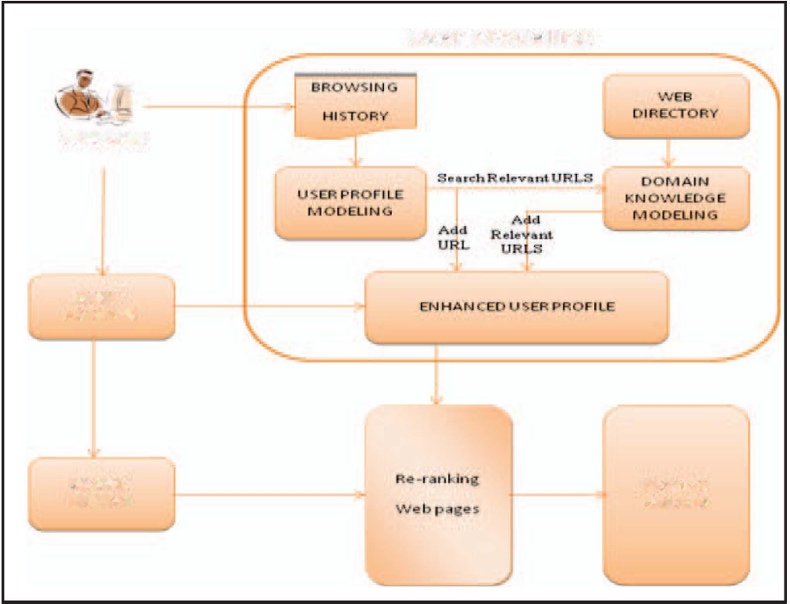

MODULE DESCRIPTION:

Number of Modules
After careful analysis the system has been identified to have the following modules:

- Personalized Web Search Module.
- User Modeling Module.
- Domain Knowledge Modeling Module.
- Enhanced User Profile Module.

- Personalized Web Search Module:
Personalized web search which considers individual's interest into mind and enhances the traditional web search by suggesting the relevant pages of his/her interest. We have proposed a simple and efficient model which ensures good suggestions as well as promises for effective and relevant information retrieval. In addition to this, we have implemented the proposed framework for suggesting relevant web pages to the user.

2. User Modeling Module:
Our system considers user's profile (based on user's weblog/navigation browsing history) and Domain Knowledge in order to perform personalized web search. Using a Domain Knowledge, the system stores information about different domain/categories. Information obtained from User Profile is classified into these specified categories. The learning agent learns user's choice automatically through the analysis of user navigation/browsing history, and creates/updates enhanced User Profile conditioning to the user's most recent choice. Once the user inputs query, the system provides good suggestions for personalized web search based on enhanced user profile. Further our model makes good use of the advantages of popular search engines, as it can re-rank the
results obtained by the search engine based on the enhanced user profile.

3.Domain Knowledge ModelingModule:
Domain knowledge is the background knowledge that we used to enhance the user profile. The source which we have used for preparing Domain Knowledge is DMOZ directory. For preparing Domain Knowledge, first we have crawled the
web pages from DMOZ directory for some specified categories, where each category is represented by collection of URL's present in that category.

4.Enhanced User Profile Module:
Using the information of user browsing history and domain knowledge, we create an Enhanced User Profile. Once the Enhanced User Profile is created, we take the user query and suggest the relevant web pages with respect the query. In our Experiment, we have used User Profile as a base case for suggesting the relevant pages and compared the results with the pages suggested from Enhanced User Profile. For each query, we suggest top 20 relevant documents from User Profile and for the same query we also suggest top 20 relevant documents from Enhanced User Profile. In order to compare the efficiency of the result, we compared the similarity of suggested documents with the user query.

SOFTWARE REQUIREMENTS:

Operating System : Windows
Technology : Java and J2EE
Web Technologies : Html, JavaScript, CSS
IDE : My Eclipse
Web Server : Tomcat
Tool kit : Android Phone
Database : My SQL
Java Version : J2SDK1.5

HARDWARE REQUIREMENTS:

Hardware : Pentium
Speed : 1.1 GHz
RAM : 1GB
Hard Disk : 20 GB
Floppy Drive : 1.44 MB
Key Board : Standard Windows Keyboard
Mouse : Two or Three Button Mouse
Monitor : SVGA

